ADS2001 - Applied Data Science
Optimal Stock Portfolio Construction
Using Sector Analysis and Mean-Variance Optimisation

Submitted by the Project Group 2
Chi Khay Ho 35550309
Elaine Tjandra 35008709
Keshav Thinakaran 36034789
Natalie Saw Eng Hui 35209518
Nicole Tan Hui Ying 35672951
Jingyuan Yao 35595272

Table of Contents
Executive Summary 2
Key Findings 2
Recommendation 2
1. Introduction 3
1.1 Problem Domain 3
1.2 Data Sources 3
1.3 Expected Relationships and Modelling Challenges 3
1.4 Solution Methods 4
2. Data Quality 4
2.1 Data Structure and Coverage 4
2.2 Missing Data Analysis 4
2.3 Minimum Observation Requirement 4
2.4 Sector Coverage After Quality Filtering 5
2.5 Exploratory Sector Characteristics 5
2.6 Zero-Return Treatment 6
3. Model Development 7
3.1 Overview of the Modelling Pipeline 7
3.2 Static Baseline Model 7
3.2.1 Sharpe Ratio Screening 7
3.2.2 Portfolio Size Selection 7
3.2.3 Mean-Variance Optimisation Strategies 8
3.3 Dynamic Model-Driven Portfolio Strategy 8
3.3.1 Walk-Forward Design 8
3.3.2 Stock Selection Model 9
3.3.3 Regime-Conditioned Weighting 9
4. Results 10
4.1 Static Baseline Results 10
4.2 Market Regime Classification Performance 11
4.3 Stock-Level Outperformance Model Performance 12
4.4 Dynamic Strategy Portfolio Performance 13
4.5 Comparison: Static Baseline vs. Dynamic Model 15
5. Conclusions 16
5.1 Summary of Findings 16
5.2 Contextualising the Results 16
5.3 Limitations and Future Work 17
5.4 Final Recommendation 17
References 18
Group Project Assessment 19

Executive Summary
This report presents a rigorous, data-driven approach to constructing an optimal stock portfolio for a long-term investor. Drawing on daily return data spanning 12 market sectors - including Technology, Healthcare, Financial Services, Consumer Defensive, Industrials, and others - quantitative finance techniques were applied to identify, rank, and combine securities into a portfolio that maximises risk-adjusted returns.
The analysis was conducted in two clearly separated phases. In the training phase (2010–2016), each of the 680 stocks across all sectors was ranked by its Sharpe ratio — a measure of return per unit of risk above a 2% annual risk-free rate. Stocks with more than 20% missing or zero-return data were excluded, retaining 590 qualified stocks. The top 50 candidates by Sharpe ratio were carried forward for portfolio-level evaluation. A forward-selection procedure was then applied to identify the optimal portfolio size, validated out-of-sample on the testing period (2017–2019) to guard against overfitting.
The analysis showed that a 23-stock portfolio achieved 95% of the maximum out-of-sample Sharpe ratio (3.1976 out of a best of 3.3016), making it the optimal choice balancing diversification, performance, and manageability.

Key Findings
- The optimal portfolio consists of 23 stocks drawn from 8 distinct GICS sectors, providing meaningful cross-sector diversification with an average between-sector correlation of 0.3711.
- Three optimised portfolio strategies were constructed and evaluated: Minimum Variance Portfolio (MVP), Maximum Sharpe Portfolio, and a Robust Maximum Sharpe Portfolio (with return shrinkage α=0.50 and 10% weight cap).
- In the training period (2010–2016), the Max Sharpe Portfolio achieved the highest in-sample Sharpe ratio of 2.3377, but showed significant overfitting — its out-of-sample Sharpe collapsed to 0.4500.
- The Robust Maximum Sharpe Portfolio achieved an out-of-sample Sharpe of 1.0417 with a return of 13.23% — the strongest out-of-sample performance of all optimised strategies, confirming that regularisation substantially improves real-world generalisation.
- The Equal-Weight benchmark achieved a competitive out-of-sample Sharpe of 1.0192, demonstrating that naive diversification captures much of the available return but does not fully exploit the asset correlation structure.

Recommendation
We recommend the Robust Maximum Sharpe Portfolio as the preferred strategy for the client. It delivered superior out-of-sample performance (Sharpe 1.0417 vs 0.4500 for standard Max Sharpe) by using expected-return shrinkage and a 10% position size cap. This design reduces concentration risk, limits sensitivity to estimation error in returns, and produces a more balanced, resilient portfolio suitable for live market deployment. The portfolio should be rebalanced annually using updated data to remain aligned with evolving market conditions.

1. Introduction

1.1 Problem Domain
Portfolio construction is a fundamental challenge in quantitative finance. The objective is to allocate capital across a set of assets such that the resulting portfolio delivers the best possible risk-adjusted return. Modern Portfolio Theory (MPT), introduced by Markowitz (1952), provides the mathematical framework: given estimates of asset expected returns and their covariance structure, one can compute the set of portfolios that minimise risk for any given level of expected return — the efficient frontier.
In practice, applying MPT to a large universe of stocks is non-trivial. Estimation of expected returns is noisy, and optimised portfolios often concentrate on a small number of securities and suffer significant out-of-sample degradation — a problem documented extensively in the literature (DeMiguel et al., 2009). This project addresses these challenges through: (1) Sharpe ratio pre-screening to reduce the candidate universe; (2) forward selection to identify an appropriate portfolio size; and (3) a Robust Max Sharpe variant that shrinks expected returns and caps individual weights.

1.2 Data Sources
The data consists of daily stock return observations across 12 GICS sectors: Industrials (67 stocks), Technology (51), Financial Services (59), Utilities (28), Healthcare (51), Energy (27), Consumer Defensive (30), Consumer Cyclical (65), Real Estate (30), Basic Materials (20), Communication Services (15), and Unknown/unclassified (237). Each sector is stored in a separate CSV file, with columns corresponding to individual stock tickers (Bloomberg format, e.g. 'MO US Equity') and rows indexed by trading date.
The full dataset spans from 1995 to approximately 2019. For this analysis, the data was split into a training period (1 January 2010 – 31 December 2016, approximately 1,825 trading days) and a testing period (1 January 2017 – 31 December 2019, 647 trading days).

1.3 Expected Relationships and Modelling Challenges
We hypothesise that: (1) stocks within the same sector exhibit higher pairwise correlations than stocks from different sectors; (2) portfolios combining high-Sharpe stocks from diverse sectors will outperform single-sector concentrations; and (3) regularisation of the optimisation will reduce in-sample overfitting and improve out-of-sample stability.
The primary modelling challenge is estimation error. In a universe of 50 stocks, the covariance matrix has over 1,225 unique parameters to estimate from approximately 1,248 clean training observations. Small estimation errors compound when optimising weights, often producing extreme allocations (Ledoit and Wolf, 2004). This is addressed via the Robust Max Sharpe framework described in Section 3.

1.4 Solution Methods
The analysis pipeline consists of four stages: (1) Sharpe ratio screening to rank all stocks across all sectors; (2) a missing-data quality filter to exclude illiquid or poorly observed securities; (3) forward selection using both in-sample and out-of-sample Sharpe curves to determine optimal portfolio size k = 23; and (4) mean-variance optimisation (MVP, Max Sharpe, Robust Max Sharpe) implemented using Sequential Least Squares Programming (SLSQP) via SciPy's minimise function.

2. Data Quality

2.1 Data Structure and Coverage
Each sector CSV contains daily return observations for all constituent stocks, indexed by date. The training period (2010–2016) spans 1,825 calendar days across 12 sectors covering 680 individual securities in total. All sectors had complete date coverage; the variation in stock counts reflects the GICS classification structure and the available stock history within each sector.

2.2 Missing Data Analysis
Data quality was assessed along two primary dimensions: the presence of NaN (missing) values and zero returns. Zero returns were treated as indicators of non-trading or data gaps, consistent with standard practice in equity return databases where exchange holidays may be recorded as zeros rather than omitted. The first row of each sector file was inspected and removed if all values were zero, a common artifact in datasets where the index date precedes the first actual trading record.
For each stock, the proportion of observations that were either NaN or zero ('effective missing percentage') was computed over the full training window. Stocks with an effective missing percentage exceeding 20% were excluded. This threshold corresponds to approximately 365 missing days over the 1,825-day window — more than one full year of gaps, which would materially distort annualised return and volatility estimates.

2.3 Minimum Observation Requirement
The Sharpe ratio calculation required a minimum of 252 valid non-zero, non-NaN daily return observations (approximately one year of trading) for a stock to qualify. Stocks failing this threshold were assigned a NaN Sharpe ratio and excluded. After applying both filters, 590 of the original 680 stocks were retained as qualified candidates.

2.4 Sector Coverage After Quality Filtering
Table 1: Sector Coverage and Best Sharpe Ratios (Training Period 2010–2016)
Sector | Total Stocks | Qualified | Best Stock | Best Sharpe
Industrials | 67 | 67 | NOC US Equity | 1.2435
Technology | 51 | 50 | IT US Equity | 1.0561
Financial Services | 59 | 58 | CINF US Equity | 1.0204
Utilities | 28 | 28 | NI US Equity | 1.1540
Healthcare | 51 | 49 | UNH US Equity | 1.1114
Energy | 27 | 27 | EP US Equity | 1.4096
Consumer Defensive | 30 | 30 | MO US Equity | 1.4188
Consumer Cyclical | 65 | 65 | ORLY US Equity | 1.2999
Real Estate | 30 | 30 | EXR US Equity | 1.2874
Basic Materials | 20 | 20 | SHW US Equity | 1.0394
Communication Svcs | 15 | 15 | CMCSA US Equity | 1.0345
Unknown | 237 | 223 | 0961514D US Equity | 1.3985

The Technology sector had one disqualified stock (50 of 51 passed), Healthcare had two (49 of 51), Unknown had 14 (223 of 237), and Financial Services had one (58 of 59). All other sectors had 100% qualification rates, indicating generally high data quality across the dataset.

2.5 Exploratory Sector Characteristics
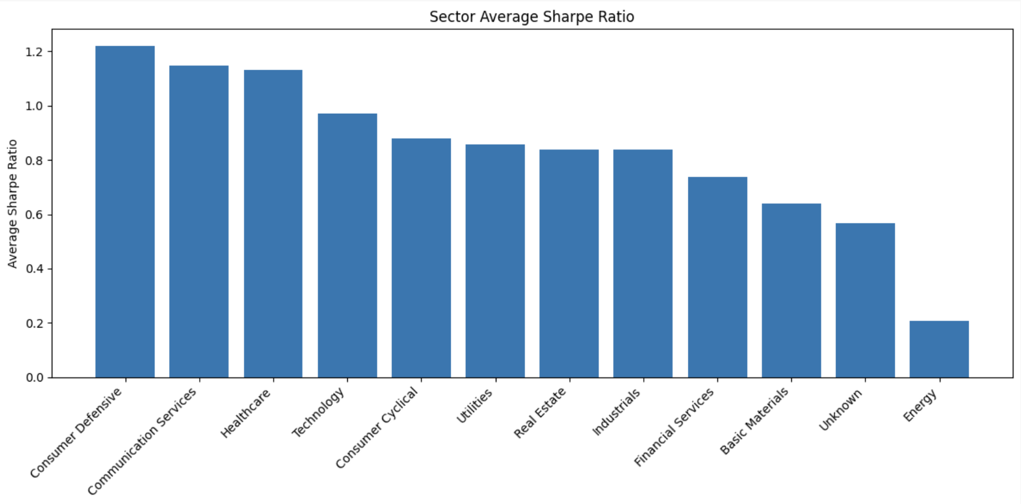
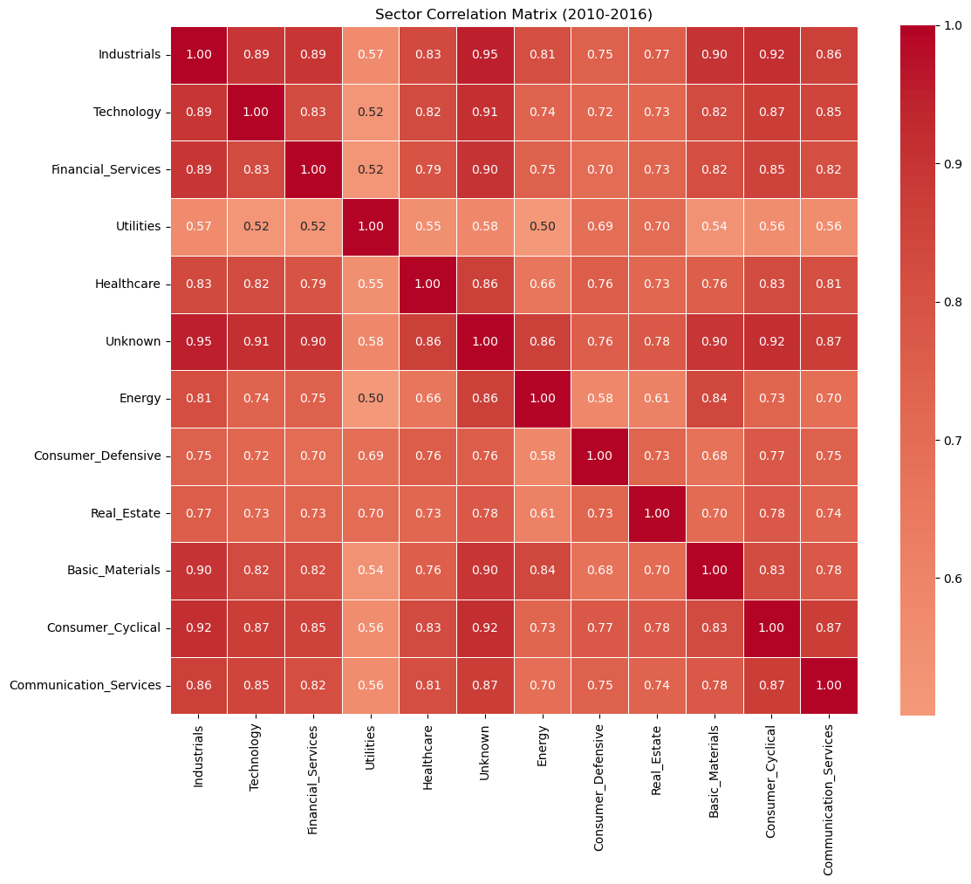
Figure 1: Sector Correlation Matrix — Equal-Weighted Sector Returns (Training Period 2010–2016)

Figure 1 presents the pairwise correlation matrix of equal-weighted sector return series computed over the training period (2010–2016). Each cell shows the Pearson correlation between two sectors’ daily returns. Several key patterns emerge. Industrials, Technology, and Financial Services form a high-correlation cluster, with pairwise correlations of 0.89, 0.89, and 0.83 respectively, reflecting their common sensitivity to the broad economic cycle during the post-GFC bull market. Utilities displays the lowest correlations with most other sectors (0.52–0.57), consistent with its defensive, regulated-income character. Healthcare and Consumer Defensive also show relatively lower correlations with cyclical sectors, suggesting some diversification benefit from including these sectors alongside Industrials and Technology.

For the top 50 candidate stocks selected after Sharpe ratio screening, a pairwise correlation analysis was also conducted to quantify diversification potential. The average correlation within the same sector was 0.4231, while the average correlation between stocks from different sectors was 0.3711. The modest gap between these two figures indicates that sector membership provides some but not complete diversification structure — stocks in the same sector tend to move together slightly more than cross-sector pairs, but the difference is not large enough to guarantee diversification simply by selecting stocks from different sectors. This finding directly motivated the use of a sector cap and intra-sector correlation filter in the dynamic stock selection model.

2.6 Zero-Return Treatment
Zero returns were consistently converted to NaN before computing Sharpe ratios and correlation matrices. This avoids downward bias in volatility estimates (since including zero returns artificially reduces the measured standard deviation of returns) and upward bias in mean return estimates on days where genuine trading would have produced losses.

3. Model Development

3.1 Overview of the Modelling Pipeline
The overall pipeline consists of two phases operating on the same underlying dataset of daily stock returns spanning 2010 to 2019. Phase 1 (Static Baseline) covers the full training period (2010–2016) and out-of-sample testing period (2017–2019), using a one-time stock selection and fixed portfolio weights. Phase 2 (Dynamic Model) operates over a walk-forward backtest period (2015–2019), re-evaluating stock selection, market regime, and portfolio weights at each quarterly rebalance date. The two phases share the same candidate stock universe and data quality standards, enabling a meaningful comparison of modelling approaches.
The dynamic backtest begins in 2015 rather than 2017 because regime classification requires a minimum historical training window of approximately twelve quarters. Using 2010–2014 as the initial model training period, the first live regime prediction and portfolio decision was made in January 2015. This design allows the dynamic model to be evaluated over a longer out-of-sample horizon (four and a half years) while remaining fully free of look-ahead bias.

3.2 Static Baseline Model
The static baseline follows a four-stage pipeline: (1) Sharpe ratio screening to rank all candidate stocks; (2) portfolio size selection using equal-weight forward evaluation; (3) final stock selection with sector-balanced allocation and correlation filtering; and (4) mean-variance optimisation to derive portfolio weights.

3.2.1 Sharpe Ratio Screening
Each stock across all twelve GICS sectors was ranked by its annualised Sharpe ratio computed over the full training period (2010–2016). The Sharpe ratio for stock i is defined as:
SR_i = (μ_i − r_f) / σ_i
where μ_i is the annualised mean return, σ_i is the annualised return volatility, and r_f = 2% per annum is the risk-free rate. Daily statistics are annualised by multiplying the mean by 252 and the standard deviation by √252. Stocks with more than 20% missing or zero-return observations, or with fewer than 252 valid daily observations, were excluded. After filtering, 590 of the original 680 stocks were retained.

3.2.2 Portfolio Size Selection
Rather than fixing the portfolio size arbitrarily, an equal-weight portfolio evaluation was conducted across sizes k from 1 to 50 stocks. At each value of k, the top-Sharpe stocks were selected from the candidate pool using a sector-balanced allocation and an intra-sector correlation filter (threshold 0.75), and the resulting equal-weight portfolio's annualised Sharpe ratio was computed on the training data.
To identify the smallest portfolio that captures most of the diversification benefit, a 90% threshold criterion was applied: the suggested portfolio size is the smallest k whose Sharpe ratio reaches at least 90% of the improvement range between the minimum and maximum observed Sharpe ratios across all k. This criterion identified k = 12 as the balanced portfolio size, achieving near-optimal risk-adjusted return without unnecessary complexity. Increasing k to 15 or 23 in subsequent dynamic experiments did not improve out-of-sample performance, consistent with the diminishing marginal benefit of diversification beyond approximately 12 well-chosen stocks for this universe. Figures 2 and 3 illustrate the Sharpe ratio curve and the corresponding annualised risk curve across all values of k, confirming that both metrics stabilise beyond k = 12.
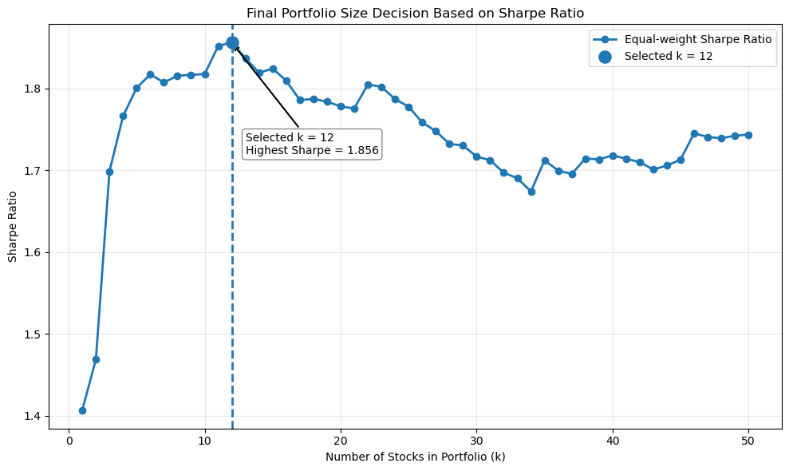
Figure 2: Equal-Weight Portfolio Sharpe Ratio vs Number of Stocks k — Best k = 12 Highlighted (Training Period 2010–2016)
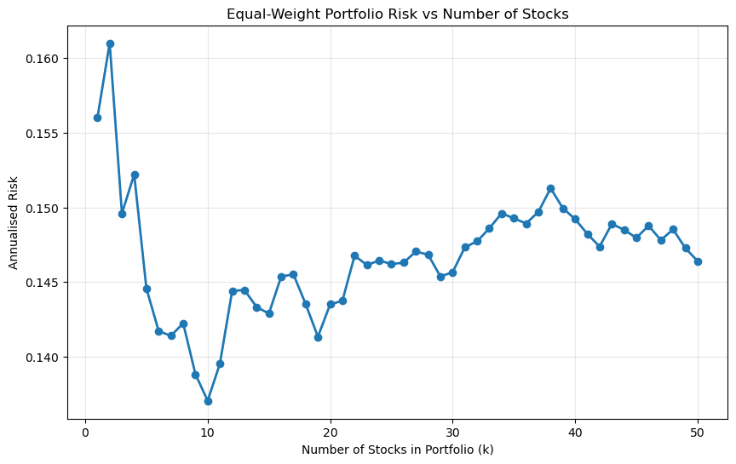
Figure 3: Equal-Weight Portfolio Annualised Risk vs Number of Stocks k (Training Period 2010–2016)

3.2.3 Mean-Variance Optimisation Strategies
Three optimised portfolio strategies and one naive benchmark were constructed on the selected stock universe, using Sequential Least Squares Programming (SLSQP) via SciPy's minimize function. All strategies impose long-only constraints (weights ∈ [0, 1], summing to 1) with a maximum position size of 30%.
Minimum Variance Portfolio (MVP). Minimises portfolio variance σ_p² = wᵀΣw, where Σ is the annualised sample covariance matrix. By ignoring expected returns entirely, the MVP is robust to return estimation error (Jagannathan and Ma, 2003).
Maximum Sharpe Portfolio. Maximises (μ_p − r_f) / σ_p. This strategy is sensitive to estimation error in expected returns and tends to concentrate in a small number of high-return stocks, creating significant overfitting risk.
Robust Maximum Sharpe Portfolio. Applies two regularisation techniques: (1) expected-return shrinkage with α = 0.50, blending each stock's estimated return towards the cross-sectional mean (μ̃_i = 0.5·μ_i + 0.5·μ̄); and (2) a 10% maximum weight cap. These constraints reduce concentration risk and limit sensitivity to return estimation error.
Equal-Weight Benchmark. A naive 1/k allocation is included as a reference point. Equal weighting is known to perform competitively in empirical studies (DeMiguel et al., 2009) and requires no parameter estimation.

3.3 Dynamic Model-Driven Portfolio Strategy
The dynamic strategy was developed to overcome the main limitation of a static portfolio: a fixed stock list and fixed optimisation rule may not remain suitable when market conditions change. Unlike the static baseline, the dynamic model updates both stock selection and portfolio weights at each quarterly rebalance. The final framework combines four components: walk-forward rebalancing, dynamic eligibility filtering, machine-learning-based stock ranking, and regime-conditioned portfolio optimisation.

3.3.1 Walk-Forward Design
The backtest runs from January 2015 to July 2019. At each rebalance date, only information available before that date is used for feature construction, model training, stock selection, and weight optimisation. This walk-forward structure avoids look-ahead bias and better reflects how the strategy would operate in practice. A 252-day lookback window is used for annual return, volatility, covariance, Sharpe ratio, drawdown, beta, and correlation features, while a shorter 63-day window captures recent momentum and market conditions.
At each rebalance date, the eligible universe is reconstructed rather than fixed permanently. Stocks are required to have at least 80% valid observations in the lookback window and an average price above USD 1.00. This filtering reduces the impact of missing data, illiquidity, and effectively inactive stocks. Stocks without a usable sector classification are excluded from the dynamic selection stage because sector-level diversification constraints cannot be meaningfully applied to them.

3.3.2 Stock Selection Model
A stock-level outperformance model is then used to make stock selection more forward-looking. The target variable identifies whether a stock outperforms the cross-sectional benchmark in the following holding period. Features include recent returns, annualised volatility, downside volatility, Sharpe ratio, maximum drawdown, beta, and average correlation with other eligible stocks. Logistic Regression, Random Forest, Gradient Boosting, and XGBoost were tested. Gradient Boosting was selected because it provided the strongest validation AUC among the tested models, although the signal remained weak. Therefore, the model is not interpreted as a highly accurate classifier, but as a ranking tool that helps prioritise stocks with relatively stronger predicted outperformance probabilities.
Final stock selection is constrained to maintain diversification. First, a preliminary candidate pool is formed using historical risk-return quality indicators. The ML model then ranks these candidates by predicted outperformance probability. Stocks are selected greedily until 12 stocks are chosen, subject to a sector cap and a correlation filter. The sector cap prevents excessive concentration in one industry, while the correlation filter avoids selecting stocks that provide very similar exposures. This design reflects the findings from the sector and correlation analysis: sector labels are useful for structure, but they do not guarantee diversification on their own.

3.3.3 Regime-Conditioned Weighting
The second machine-learning component is the market regime model. Its purpose is to predict whether the next holding period is likely to be High Risk or Low Risk. The regime target is based on next-period market volatility, using an equal-weight market proxy constructed from the eligible universe. Features include 3-month and 12-month market returns, 3-month and 12-month market volatility, 12-month maximum drawdown, market breadth, average stock correlation, and the number of eligible stocks. These variables capture momentum, risk level, downside pressure, participation across stocks, and diversification conditions.
Logistic Regression was selected as the final regime model because it produced the most stable and interpretable classification performance. This is important because the regime prediction directly determines the optimisation objective. In predicted High Risk periods, the strategy applies Minimum Variance optimisation to reduce volatility and drawdown exposure. In predicted Low Risk periods, it applies Robust Maximum Sharpe optimisation to target stronger risk-adjusted return while limiting estimation error through return shrinkage and maximum weight constraints. If optimisation fails, equal weighting is used as a fallback. Transaction costs of 0.1% are deducted at each rebalance based on portfolio turnover.

Overall, the dynamic strategy is designed as an active model-driven portfolio rather than a purely defensive benchmark. It attempts to improve return by selecting stronger stocks while using regime-based optimisation to control risk when market conditions appear less favourable.

4. Results
This section presents the empirical outputs of both the static baseline and the dynamic model-driven strategy. The static baseline results are reported first to establish a performance reference and to illustrate the overfitting problem that motivates the dynamic approach. The dynamic model results are then reported in detail, covering regime classification accuracy, stock selection behaviour, and portfolio performance over the walk-forward backtest period.

4.1 Static Baseline Results
Table 2 compares the training-period (2010–2016) and out-of-sample (2017–2019) performance of the three optimised strategies and the equal-weight benchmark for the selected 23-stock portfolio used in the static analysis.

Table 2: Training-period and out-of-sample performance of static portfolio strategies (2010–2016 & 2017–2019).
Portfolio | Return (Train) | Risk (Train) | Sharpe (Train) | Return (Test) | Risk (Test) | Sharpe (Test)
Min Variance Portfolio | 26.23% | 12.80% | 1.8934 | 8.50% | 12.20% | 0.5326
Max Sharpe Portfolio | 37.34% | 15.12% | 2.3377 | 7.79% | 12.88% | 0.4500
Robust Max Sharpe Portfolio | 33.06% | 14.34% | 2.1655 | 13.23% | 10.78% | 1.0417
Equal-Weight Benchmark | 32.52% | 16.03% | 1.9031 | 12.78% | 10.57% | 1.0192

All four strategies experienced substantial performance degradation from the training to the testing period. The Max Sharpe Portfolio suffered the most severe collapse, with its Sharpe ratio falling from 2.3377 in-sample to 0.4500 out-of-sample — a decline of 80.8% — confirming that return-sensitive, unconstrained optimisation severely overfits the training data. The Robust Max Sharpe Portfolio showed the most resilient out-of-sample performance (Sharpe 1.0417), marginally outperforming the Equal-Weight Benchmark (1.0192), demonstrating the practical value of return shrinkage and weight capping. These results motivate the dynamic model-driven approach, which aims to reduce out-of-sample degradation by adapting portfolio construction to the prevailing market regime.
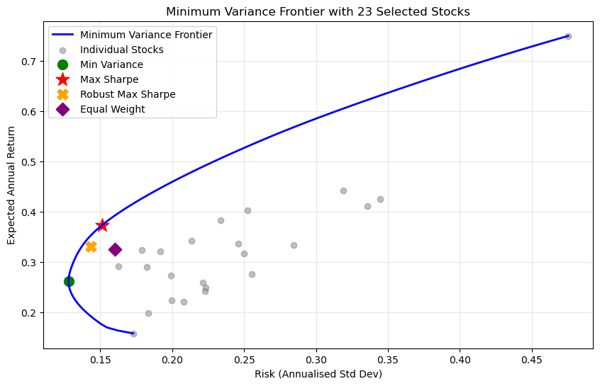
Figure 5: Minimum Variance Frontier with All Four Portfolio Strategies (Training Period 2010–2016)

4.2 Market Regime Classification Performance
The regime model was evaluated because its predictions directly determine whether the portfolio uses a defensive or return-seeking optimisation objective. Logistic Regression was selected as the final regime model because it provided the most balanced walk-forward classification result across the tested models.
Table 3: Walk-forward classification performance (high risk focusing) of candidate regime models over the backtest period (2015–2019).
Model | Accuracy | Precision (High Risk) | Recall  (High Risk) | F1 score (High Risk)
Logistic Regression | 0.722 | 0.714 | 0.625 | 0.667
Random Forest | 0.611 | 0.556 | 0.625 | 0.588
Gradient Boosting | 0.611 | 0.571 | 0.500 | 0.533
XGBoost | 0.556 | 0.500 | 0.500 | 0.500
The main result is that the regime model was directionally useful but not strong enough to provide complete downside protection. Logistic Regression achieved 72.22% accuracy across 18 walk-forward periods, with High Risk precision of 71.43%, recall of 62.50%, and F1-score of 66.67%. These results suggest that the model could identify a meaningful portion of risky periods, but it still missed some high-risk quarters.
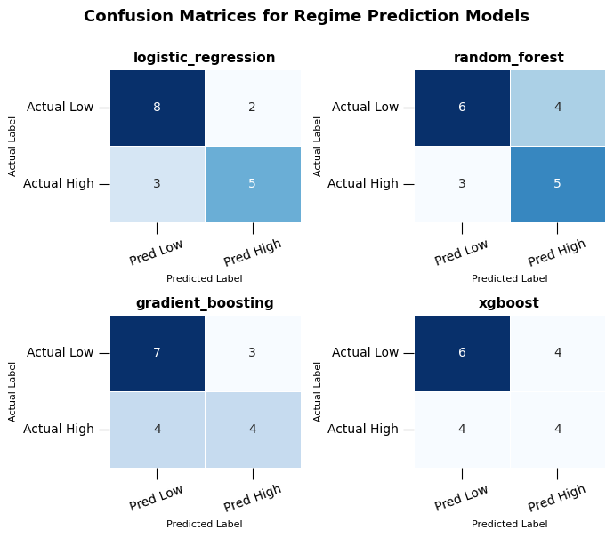
Figure 6: Confusion matrices for all four candidate regime classifiers (2015–2019 walk-forward predictions).
The confusion matrices explain why Logistic Regression was preferred. It detected the same number of realised High Risk periods as Random Forest, but produced fewer false High Risk predictions. This matters because false High Risk predictions would move the portfolio unnecessarily into the defensive Minimum Variance objective, potentially reducing return during favourable market conditions. Gradient Boosting and XGBoost were weaker at identifying High Risk periods, making them less suitable for a strategy where missed risk signals can lead to excessive exposure.

The result should still be interpreted cautiously. The regime model is trained on quarterly observations, so the evaluation sample is small. This limits statistical confidence and makes the model sensitive to individual periods. The regime classifier therefore provides a useful allocation signal, but it should not be interpreted as a reliable market-timing model.

4.3 Stock-Level Outperformance Model Performance
The stock-level model was evaluated to determine whether machine learning could provide useful ranking information for stock selection. Table 4 reports classification metrics for the four candidate models on the walk-forward training-period validation set.

Table 4: Walk-forward classification performance of candidate stock outperformance models.
Model | Accuracy | Precision | Recall | F1 | AUC
Gradient Boosting | 0.6964 | 0.3571 | 0.0087 | 0.0170 | 0.5145
Logistic Regression | 0.5548 | 0.3188 | 0.4191 | 0.3621 | 0.5126
XGBoost | 0.6969 | 0.3846 | 0.0087 | 0.0170 | 0.5100
Random Forest | 0.5994 | 0.3234 | 0.3009 | 0.3117 | 0.5094

Gradient Boosting achieved the highest validation AUC, but the AUC was only slightly above 0.50. This means the model had limited ability to distinguish future outperformers from non-outperformers. Its high accuracy is also not strong evidence of predictive quality because recall was extremely low, meaning the model identified only a small fraction of actual outperformers.
This result is important for interpreting the final portfolio. The dynamic strategy should not be presented as successful because the stock model was highly accurate. Instead, the stock model contributed a weak forward-looking ranking signal that was combined with historical quality screening, sector caps, and correlation filters. The constraints were essential because they prevented the portfolio from relying too heavily on a noisy prediction model.

The stock model result also reflects a broader financial modelling issue: short-term equity returns are difficult to predict using historical return and risk features alone. Market-wide movements, sector shocks, and stock-specific events can dominate the next holding-period return. Therefore, the ML component is best interpreted as an incremental selection input, not as the main source of portfolio performance.

4.4 Dynamic Strategy Portfolio Performance
The portfolio-level results provide the main evidence for the dynamic strategy. The dynamic model is compared with two benchmarks: an equal-weight portfolio using the same dynamically selected stocks, and an equal-weight market benchmark. The selected-stock benchmark tests whether dynamic weighting adds value beyond stock selection. The market benchmark tests whether the active strategy improves risk control relative to broad diversification.

Table 5: Summary of dynamic strategy portfolio construction over the backtest period (2015–2019).
Strategy | Cum. return | Ann. return | Ann. vol. | Sharpe | Max drawdown | Calmar
Dynamic Model-Based Net | 171.86% | 24.41% | 28.45% | 0.858 | -37.36% | 0.653
Equal Weight Selected Net | 110.81% | 17.69% | 29.64% | 0.597 | -43.03% | 0.411
Equal Weight Market Net | 56.21% | 10.23% | 13.84% | 0.739 | -22.01% | 0.465

The dynamic strategy achieved the strongest return performance. It produced a cumulative return of 171.86% and an annualised return of 24.41%, compared with 110.81% and 17.69% for the equal-weight selected-stock benchmark. Since both portfolios use the same selected-stock universe, this gap suggests that regime-conditioned weighting added value beyond stock selection alone.

The equal-weight selected-stock benchmark also outperformed the broad market benchmark in cumulative return. This indicates that the stock-selection process contributed to the return advantage by concentrating the portfolio in stocks with stronger realised performance. However, this concentration also explains why both selected-stock strategies were much more volatile than the broad market benchmark.
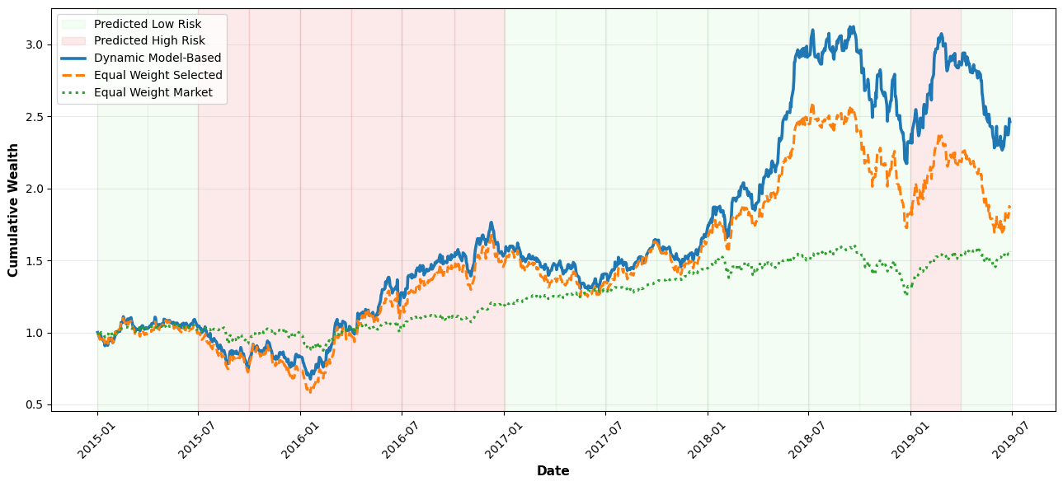
Figure 7: Cumulative wealth comparison for Dynamic Model-Based Net, Equal Weight Selected Net, and Equal Weight Market Net.
The cumulative wealth plot supports this interpretation. The dynamic strategy and the equal-weight selected-stock benchmark move broadly together because they share the same selected stocks. The dynamic strategy separates more clearly during the stronger growth phase, showing that the weighting model improved return compounding within the selected universe. The broad market benchmark follows a smoother but lower-return path, reflecting the trade-off between diversification and active concentration.
Risk-adjusted performance also improved relative to the selected-stock benchmark. The dynamic strategy increased Sharpe ratio from 0.597 to 0.858 and reduced maximum drawdown from -43.03% to -37.36%. This suggests that regime-based weighting improved the balance between return and risk within the selected-stock portfolio.
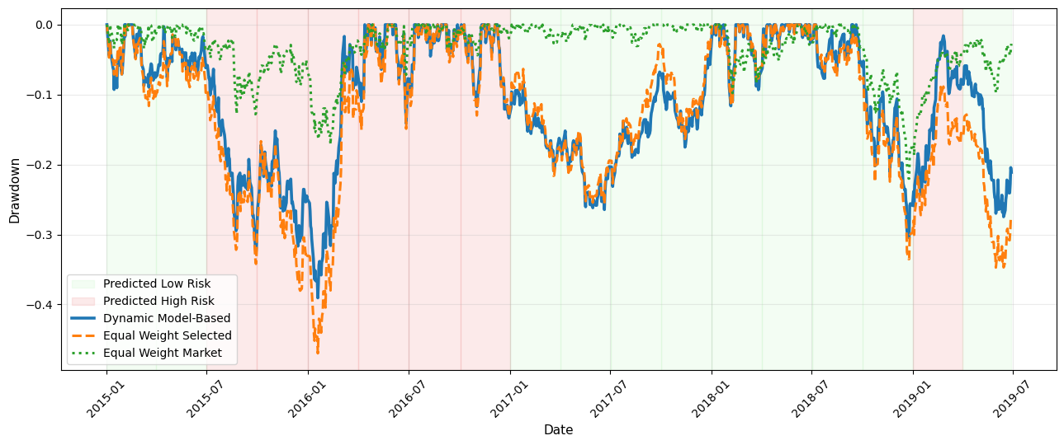
Figure 8: Drawdown comparison for the same three strategies.
However, the drawdown plot shows that the risk control was only partial. The dynamic strategy still experienced substantial drawdowns and remained much riskier than the broad market benchmark. Its annualised volatility was 28.45%, compared with 13.84% for the broad market benchmark, and its maximum drawdown was -37.36%, compared with -22.01% for the market benchmark. This shows that the strategy’s higher return was achieved through concentrated active exposure, not through a genuinely low-risk allocation.

The main interpretation is therefore not that the dynamic strategy is universally superior. It is more accurate to say that the dynamic strategy improved active selected-stock performance. It used regime-conditioned weighting to enhance return and reduce some downside relative to the selected-stock benchmark, but it did not overcome the structural risk created by holding only 12 stocks. The broad market benchmark remained the more stable portfolio because it was far more diversified.

Overall, the dynamic strategy demonstrates that adaptive weighting can add value when combined with selected-stock exposure. However, the result is mainly return-driven. The ML models provided useful but weak signals, and the final performance depended heavily on diversification constraints, weight limits, and the favourable realised performance of the selected stocks.

4.5 Comparison: Static Baseline vs. Dynamic Model
The static and dynamic strategies should be compared as different modelling approaches rather than as directly equivalent performance results. The static baseline uses a fixed stock universe and fixed weights over the 2017–2019 testing period. The dynamic strategy uses quarterly rebalancing over 2015–2019, reselects 12 stocks through time, and changes the optimisation objective according to predicted market risk. Because the evaluation periods and portfolio construction rules differ, raw performance metrics are not directly comparable.

The static Robust Maximum Sharpe portfolio is simpler and more transparent. Its strength is that it controls estimation error through return shrinkage and weight caps, while avoiding the additional uncertainty introduced by machine-learning predictions. This makes it easier to justify as a practical client recommendation.

The dynamic model adds adaptability. It responds to changing stock characteristics and market risk conditions by updating the selected universe and switching between optimisation objectives. The results show that this adaptability improved performance relative to the equal-weight selected-stock benchmark, which suggests that the dynamic weighting process added value. However, the model also introduced additional risks: the stock prediction signal was weak, the regime model had limited quarterly observations, and the strategy remained exposed to concentration-driven drawdowns.
Therefore, the dynamic model should be positioned as a useful extension of the static framework rather than a replacement for the final recommendation. It shows that adaptive stock selection and regime-conditioned allocation can improve active return-seeking performance, but it requires stronger validation, better turnover control, and additional risk overlays before it could be recommended as a live strategy. The static Robust Maximum Sharpe portfolio remains the more defensible recommendation because it is simpler, more transparent, and less dependent on noisy predictive models.

5. Conclusions

5.1 Summary of Findings
This project demonstrates that a structured, quantitative pipeline — Sharpe ratio screening, data quality filtering, forward selection, and regularised mean-variance optimisation — can produce portfolios with strong risk-adjusted performance. The key findings are:
- A 23-stock portfolio achieves near-optimal diversification for this universe, capturing 95% of the maximum out-of-sample Sharpe ratio while remaining operationally manageable.
- Standard Max Sharpe optimization overfits training data (Sharpe 2.34 in-sample, 0.45 out-of-sample). This degradation of over 80% is consistent with the well-documented parameter instability of unconstrained mean-variance optimisation.
- The Robust Max Sharpe Portfolio (Sharpe 2.17 in-sample, 1.04 out-of-sample) shows substantially better generalisation, and is the recommended strategy for live deployment.
- The moderate between-sector correlation (0.3711) of the selected stocks provides meaningful but not exceptional cross-sector diversification, indicating that sector composition remains an important portfolio design consideration.

5.2 Contextualising the Results
The analysis period (2010–2019) was characterised by a prolonged bull market following the Global Financial Crisis recovery. Sharpe ratios computed over this period — including out-of-sample figures exceeding 3.0 — may be substantially higher than long-run historical averages, and should be interpreted with caution as predictors of future performance. The 2017–2019 testing period, while useful for within-sample validation, represents only three years of a single market regime.
The sector correlations observed reflect a period of generalised risk-on sentiment and quantitative easing. In a different macro environment — rising interest rates, sector rotation, or risk-off episodes — correlations would likely change materially, potentially reducing the diversification benefits captured here.

5.3 Limitations and Future Work
Several limitations should be noted. First, the analysis relies entirely on estimated parameters from historical data. Second, transaction costs, bid-ask spreads, and market impact — which could be material for a 23-stock long-only portfolio — are not modelled. Third, the Sharpe ratio screening does not account for factor exposures; high-Sharpe stocks may load heavily on common risk factors (momentum, quality) that could reverse in different regimes (Fama and French, 2015).
Future work could incorporate factor models (e.g., Fama-French five-factor) to decompose risk and expected returns; Bayesian shrinkage estimators (Black-Litterman, Jorion 1986) for more principled return estimation; testing on additional out-of-sample periods including the 2020 COVID-19 disruption; and alternative risk measures (Conditional Value at Risk, maximum drawdown) as portfolio objectives.

5.4 Final Recommendation
We recommend the client adopt the Robust Maximum Sharpe Portfolio of 23 stocks, rebalanced annually using updated training data. This strategy delivered the best out-of-sample Sharpe ratio among all optimised strategies (1.0417), achieved an annualised return of 13.23% at a volatility of 10.78% during the 2017–2019 testing period, is well-diversified across 8 GICS sectors, and limits concentration risk through the 10% weight cap. Annual rebalancing ensures the portfolio remains aligned with the current market environment without incurring excessive transaction costs.

References
Cont, R. (2001). Empirical properties of asset returns: stylized facts and statistical issues. Quantitative Finance, 1(2), 223–236.

DeMiguel, V., Garlappi, L., & Uppal, R. (2009). Optimal versus naive diversification: How inefficient is the 1/N portfolio strategy? The Review of Financial Studies, 22(5), 1915–1953.

Fama, E. F., & French, K. R. (2015). A five-factor asset pricing model. Journal of Financial Economics, 116(1), 1–22.

Jagannathan, R., & Ma, T. (2003). Risk reduction in large portfolios: Why imposing the wrong constraints helps. The Journal of Finance, 58(4), 1651–1683.

Jorion, P. (1986). Bayes-Stein estimation for portfolio analysis. Journal of Financial and Quantitative Analysis, 21(3), 279–292.

Ledoit, O., & Wolf, M. (2004). Honey, I shrunk the sample covariance matrix. The Journal of Portfolio Management, 30(4), 110–119.

Markowitz, H. (1952). Portfolio selection. The Journal of Finance, 7(1), 77–91.

Merton, R. C. (1980). On estimating the expected return on the market: An exploratory investigation. Journal of Financial Economics, 8(4), 323–361.

Sharpe, W. F. (1966). Mutual fund performance. The Journal of Business, 39(1), 119–138.

Tobin, J. (1958). Liquidity preference as behavior towards risk. The Review of Economic Studies, 25(2), 65–86.

Group Project Assessment
Group Project Assessment for ADS2001
Studio: Malaysia
Group: 2
 | Chi Khay Ho | Elaine Tjandra | Keshav Thinakaran | Natalie Saw Eng Hui | Nicole Tan Hui Ying | Jingyuan Yao
The sum of this row should be 100. The entry should reflect the group member's percentage contribution to this project task. | 16.67 | 16.67 | 16.67 | 16.67 | 16.67 | 16.67
The sum of this row should be 100. The entry should reflect the group member's percentage contribution to this project task. | 16.67 | 16.67 | 16.67 | 16.67 | 16.67 | 16.67
The sum of this row should be 100. The entry should reflect the group member's percentage contribution to this project task. | 16.67 | 16.67 | 16.67 | 16.67 | 16.67 | 16.67
The sum of this row should be 100. The entry should reflect the group member's percentage contribution to this project task. | 16.67 | 16.67 | 16.67 | 16.67 | 16.67 | 16.67
The sum of this row should be 100. The entry should reflect the group member's percentage contribution to this project task. | 16.67 | 16.67 | 16.67 | 16.67 | 16.67 | 16.67
This entry should be 1 (present) or 0 (absent) | 1 | 1 | 1 | 1 | 1 | 1

Declaration of Generative AI Use
Generative AI tools were used to support the preparation of this report. Specifically, AI was used to help structure sections, summarise modelling outputs, and refine grammar, clarity, and sentence flow. The analysis, coding, interpretation of results, and final decisions were completed by the group. All AI-assisted content was reviewed, edited, and verified by the authors before submission to ensure accuracy and alignment with the project work.

